**Data Analysis and Documentation for "Cuisines of Uttar Pradesh and Its Tourism**

**NAME: Arushi Shivhare , PRN: 22070521062, Sem/Sec: 6A, Sub: Data science**

**1. Brief Overview of the Dataset**

Your dataset consists of various famous cuisines of Uttar Pradesh, categorized into vegetarian and non-vegetarian dishes. The dataset includes:

* **Region-specific cuisines** (e.g., Lucknow, Kanpur, Varanasi).
* **Key ingredients** used in each dish.
* **Nutritional composition** (e.g., protein, fiber, vitamins, iron levels).
* **Description** of the dishes, including historical or cultural significance.
* **Online popularity metrics** (YouTube views, likes, comments, etc.), reflecting digital engagement with these dishes.

This dataset is valuable for analyzing the correlation between cuisine popularity and tourism trends in Uttar Pradesh.

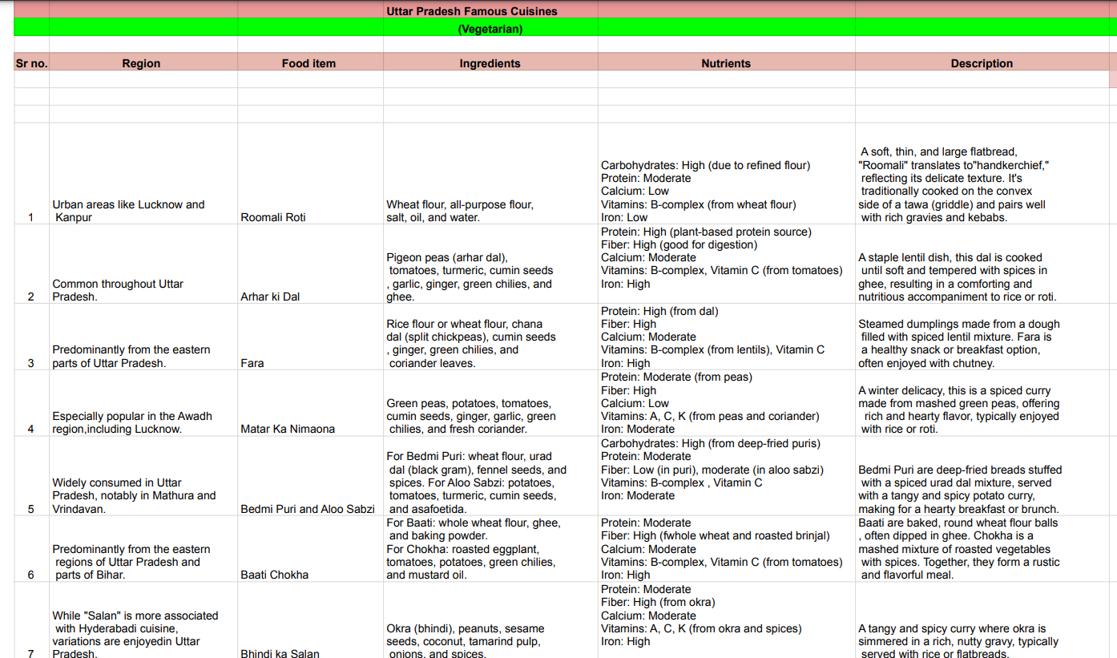

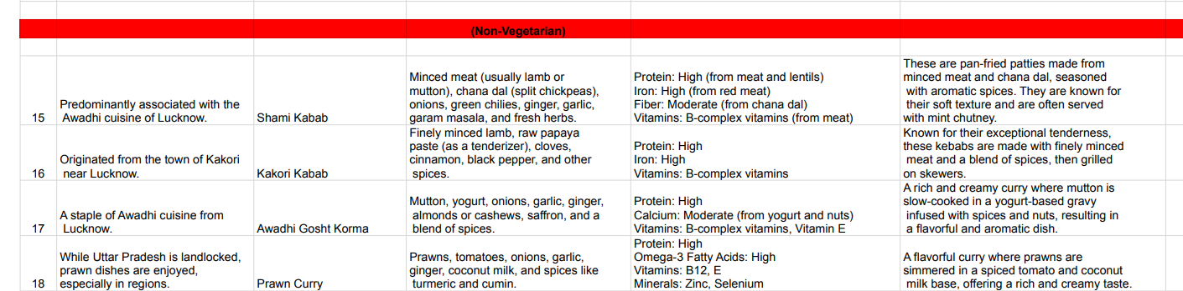

**2. Methodology for Data Analysis**

To analyze this dataset, the following methodology can be used:

**Step 1: Data Cleaning & Preprocessing**

* Handling missing values, ensuring all ingredients, nutrients, and regions are correctly labeled.
* Standardizing food category labels (vegetarian, non-vegetarian).
* Removing duplicates or irrelevant data points.

**Step 2: Exploratory Data Analysis (EDA)**

* **Nutritional Insights:** Identifying the healthiest cuisines based on protein, fiber, and vitamin content.
* **Regional Specialties:** Analyzing which cities contribute the most to food tourism.
* **Digital Popularity:** Correlating YouTube engagement metrics with famous dishes.
* **Heatmaps & Graphs:** Visualizing data through histograms, pie charts, and bar plots for better interpretation.

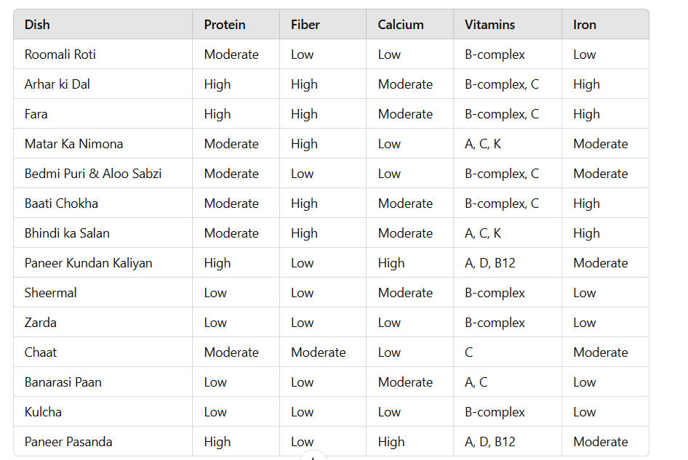

**Step 3: Sentiment Analysis (Based on Survey Responses)**

* If survey data from Google Forms is available, we can analyze:
  + User preferences for certain cuisines.
  + The influence of food on tourism choices in Uttar Pradesh.
  + Feedback on which dishes attract more tourists.
* **Link for google form:** <https://docs.google.com/forms/d/e/1FAIpQLSch4vES5vNAZe_Q0-6BSEckCRmnTEPZmDTsua0wYKDCOJorNw/viewform?usp=sharing>
* **Responses:**

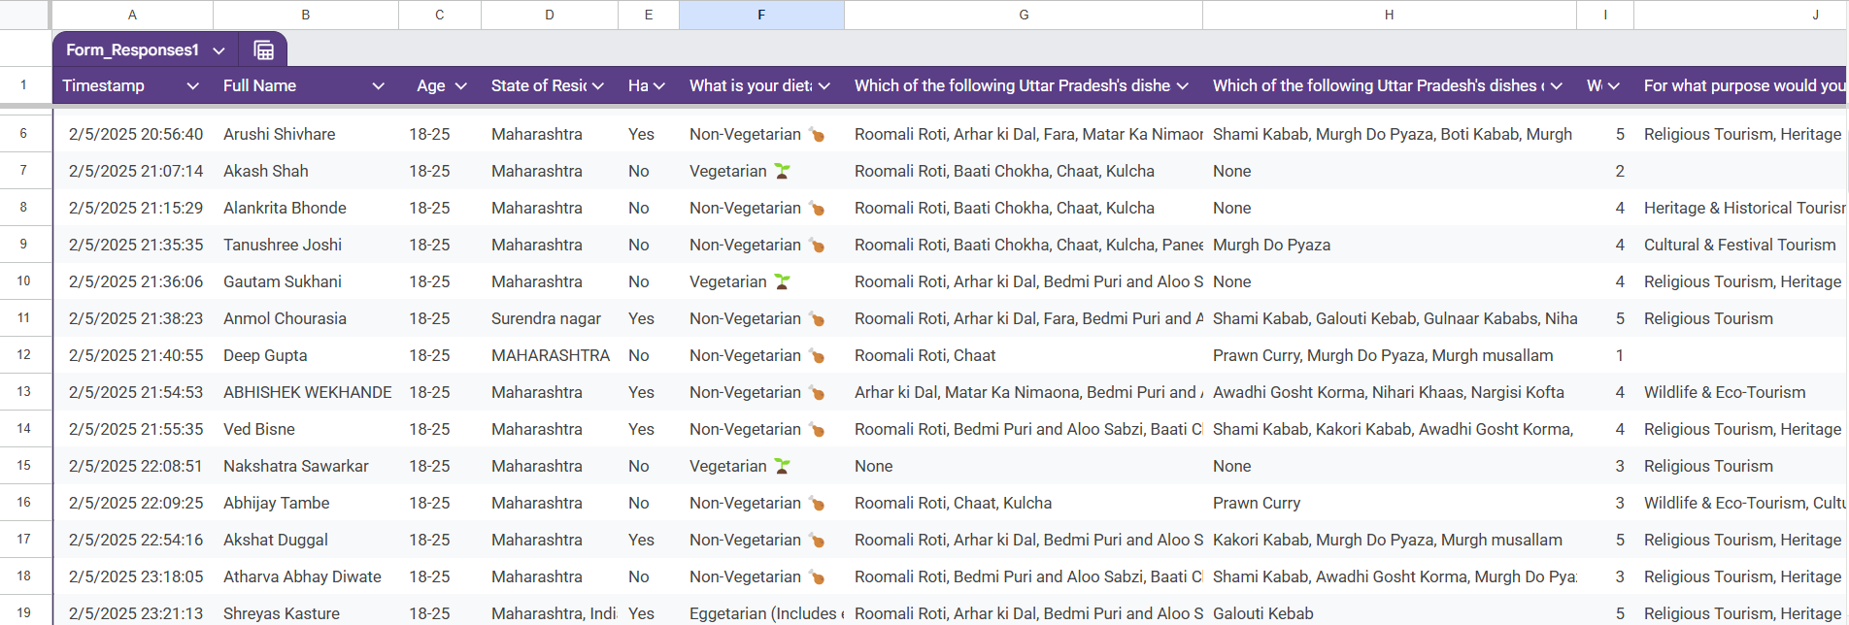

* **Visualization:**

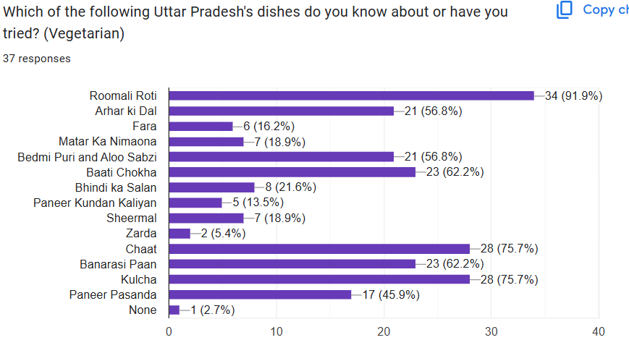

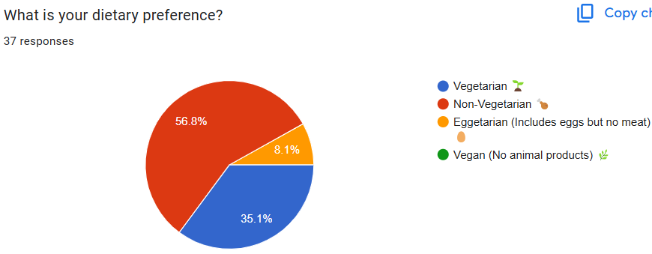

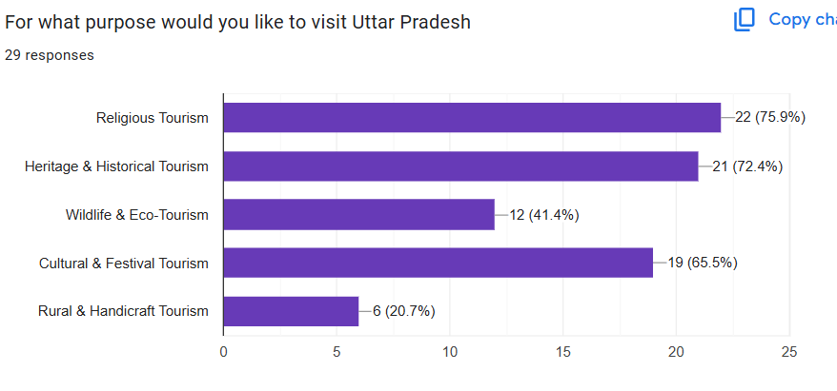

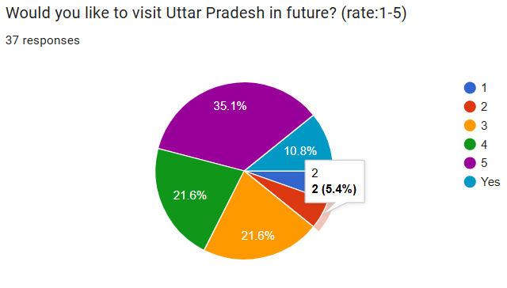

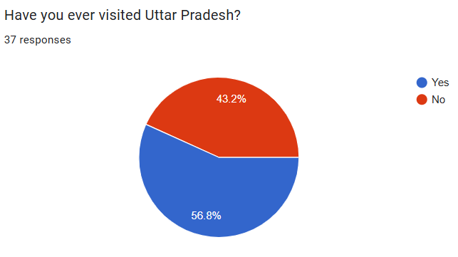

**Step 4: Machine Learning for Prediction**

* Using ML algorithms (e.g., Decision Trees, Random Forest) to predict the **most preferred cuisine in each region** based on collected data.

**3. Literature Review on Food & Tourism in Uttar Pradesh**

**Literature Review on the Intersection of Cuisines and Tourism in Uttar Pradesh**

The intricate relationship between regional cuisines and tourism has garnered significant scholarly attention, emphasizing how local culinary practices can enhance tourist experiences and promote destinations. This review delves into the role of Uttar Pradesh's cuisines, particularly Awadhi cuisine, in influencing tourism, and examines the impact of digital media on food tourism.

**1. Culinary Tourism in Uttar Pradesh**

Uttar Pradesh, with its rich cultural tapestry, offers a diverse culinary landscape that significantly contributes to its tourism appeal. The state's traditional dishes not only provide gastronomic pleasure but also offer insights into its history and culture.

A study focusing on the Awadh region highlights that food plays a pivotal role in attracting tourists, as it reflects the region's culture and lifestyle. The research underscores that cuisines have a substantial impact on travelers' decisions when choosing their destinations. The study emphasizes the importance of promoting local foods to enhance the visitor experience by connecting consumers to the region's culture and heritage.Further research examining the influence of Awadhi cuisine on tourists' food preferences in Lucknow identifies key factors that enhance guest satisfaction. The study reveals that the quality and authenticity of traditional dishes, use of local raw materials, and price affordability are crucial in promoting Awadhi food as a tourism product. These dimensions are positively related to perceiving Awadhi food service quality, thereby supporting Lucknow as a tourist destination.

**2. The Role of Digital Media in Food Tourism**

In the contemporary digital age, social media platforms have become instrumental in shaping tourists' perceptions and choices, especially concerning culinary experiences. The rapid growth of social media channels and online promotion vehicles has transformed how destinations and their culinary offerings are marketed.A study analyzing the role of information technology in food tourism marketing highlights that social media channels significantly influence the perception, choices, and decisions of food tourists at all stages of travel. The research indicates a positive relationship between social media platforms and tourists' engagement with culinary destinations, suggesting that effective digital marketing strategies can enhance a destination's appeal. Moreover, research focusing on the influence of social media on the tourism industry, particularly through platforms like Instagram, reveals that visual content significantly impacts tourists' destination choices. The study emphasizes the importance of curated digital content in attracting tourists to culinary destinations.

**3. Culinary Heritage and Gastronomy Tourism Promotion**

The culinary heritage of the Awadh region serves as a key factor in promoting gastronomy tourism. Research indicates that deliberate travel experiences driven by an interest in food and beverages, encompassing educational components that delve into the cultural significance of culinary products, have substantially increased tourism's role in driving economic growth in Awadh.

**References**

* Manish Rai, "Culinary Tourism in Awadh Region of Uttar Pradesh," International Journal of Hospitality and Tourism Systems, Vol. 9, No. 1, 2016.
* Sandeep Kumar Singh and Dhananjay Kumar Srivastav, "Influence of Awadh Cuisine on Tourists' Food Preferences While Visit Lucknow," Anvesak, Vol. 53, No. 1(I), 2023.
* Liang Mengjia et al., "A Review on Social Media as a New Venue for Promoting Culinary Destinations," Gastronomy Tourism, Vol. 10, No. 2, 2023.
* Angela White, "The Influence of Social Media on the Tourism Industry: A Content Analysis of Culinary Tourism Brands via Instagram," Master's Thesis, East Tennessee State University, 2021.
* Sandeep Kumar Singh et al., "Culinary Heritage of Awadh Region: Key Factor for Gastronomy Tourism Promotion," International Journal of Research and Analytical Reviews, Vol. 7, No. 3, 2020.
* Sandeep Kumar Singh and Dhananjay Kumar Srivastav, "A Study of Lucknow: International Tourists' Perspective on Local Awadhi Food," Journal of Emerging Technologies and Innovative Research, Vol. 6, No. 2, 2019.